RUNGTA INTERNATIONAL SKILLS UNIVERSITY
A
Practical Records of
Web.Tech
Computer Science and Engineering- Sem 1


SESSION: 2025-26

Submitted to- Submitted by-
Kavita Mam Shivam Kumar
ERP NO-11368

1.Create a basic HTML web page using heading, paragraph, and text formatting tags.
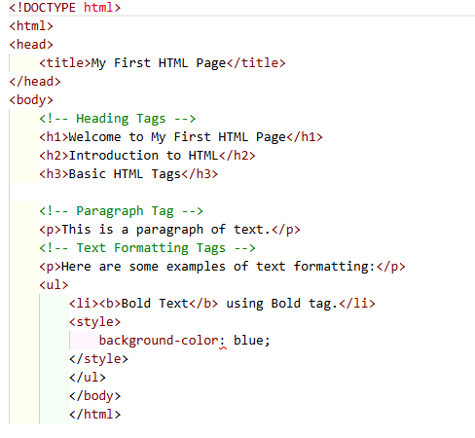
Output:
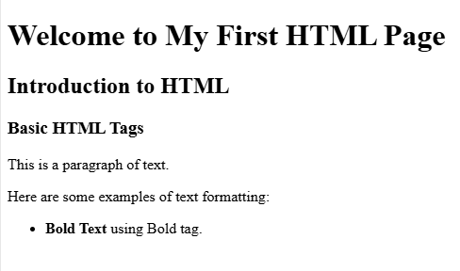

2.Design a webpage demonstrating HTML links.and image.
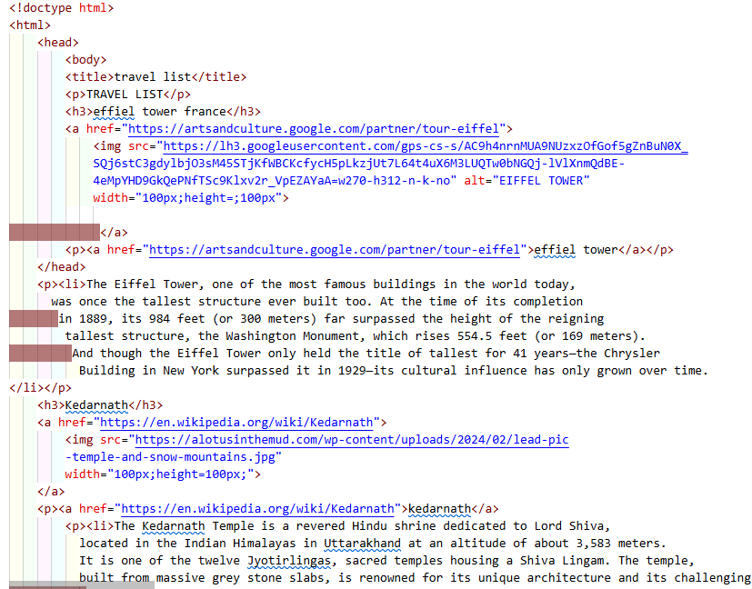
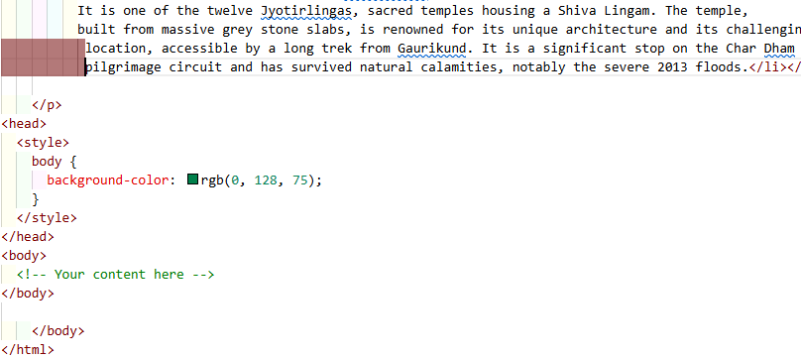

Output:
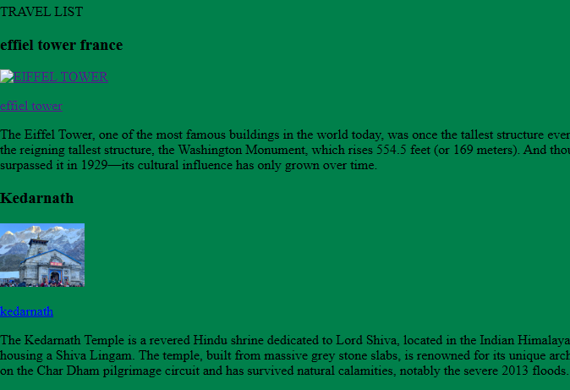
3. Create a table-based layout with merged cell, alignment, and caption using HTML.
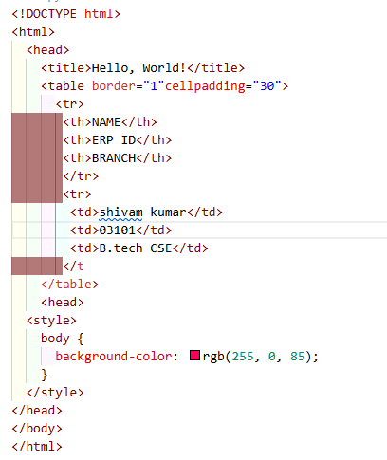

Output:
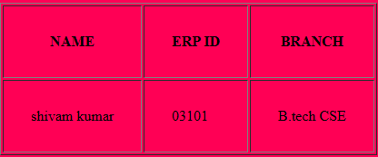

4.Design a webpage with an HTML form having text input, radio buttons, checkb ox, select
menusubmit/reset buttons .
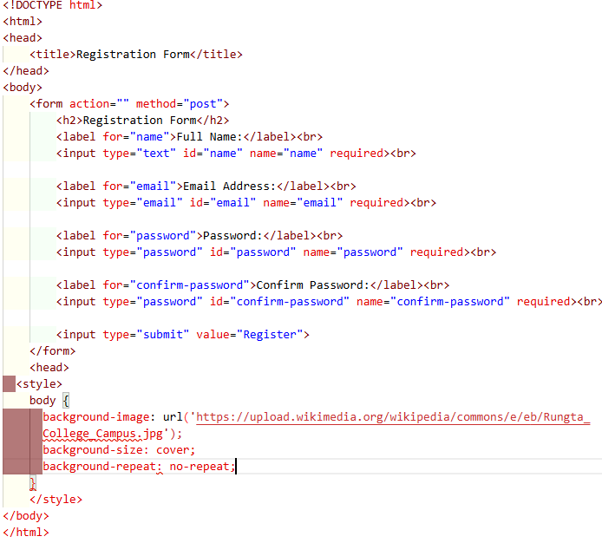

OUTPUT:-
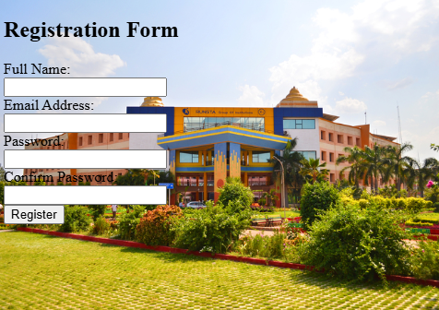

5. Use semantic elements (<article>, <section>, <nav>, <aside>, <footer>) to build a structured web page.
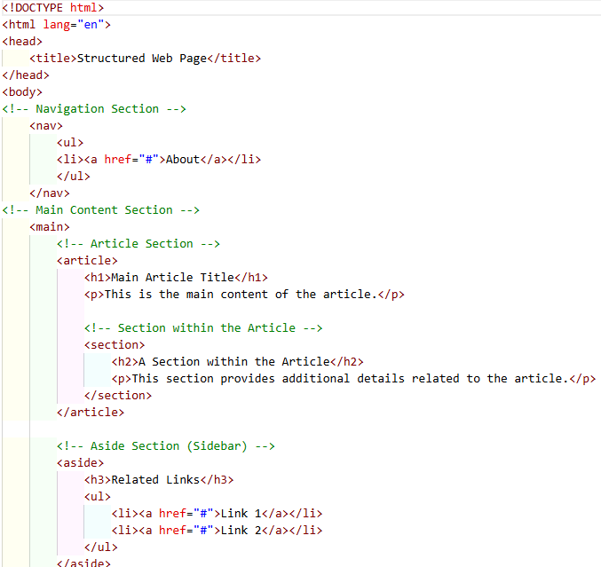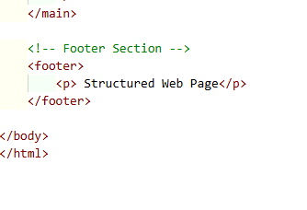

Output:
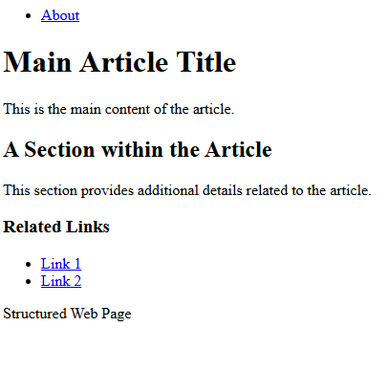

6.Apply Inline, Iternal, and External CSS style to HTML elements.
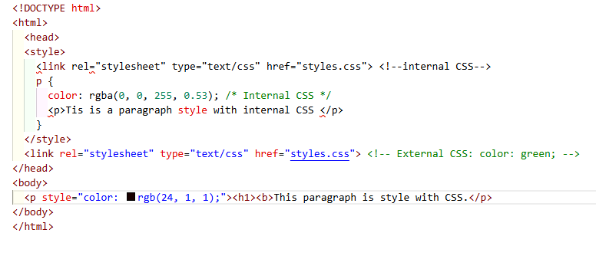
Output:
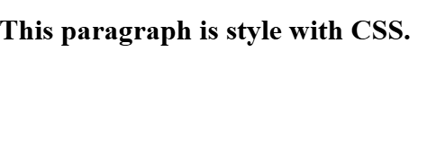
7. Style a web page using advanced CSS: Box Model, background images, borders, margins, and padding.
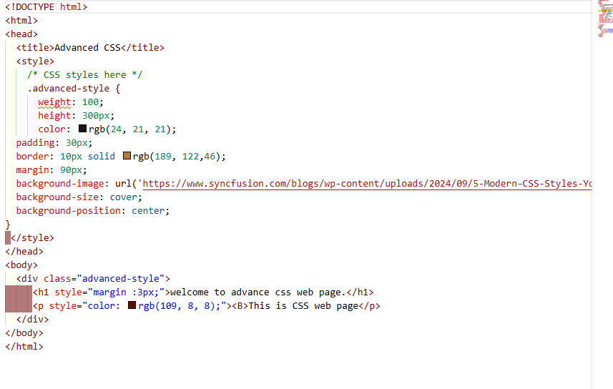
Output:
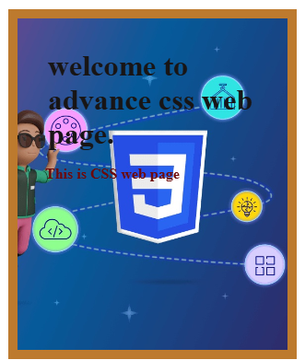

8. Demonstrate the use of different CSS selector (class, id, descendant, group, universal)
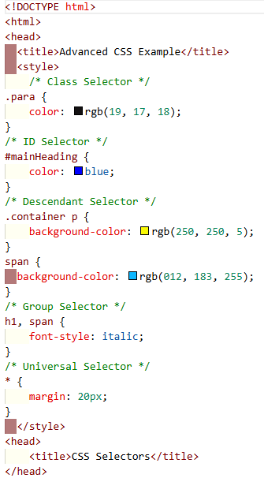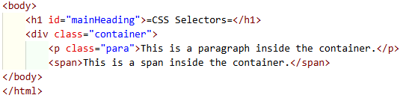

Output:
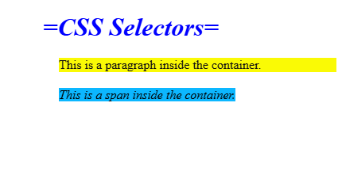

9. Create a responsive web page using media queries and mobile-first design with flexible units.
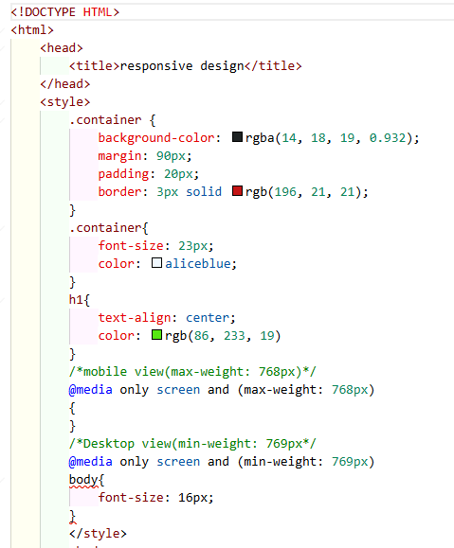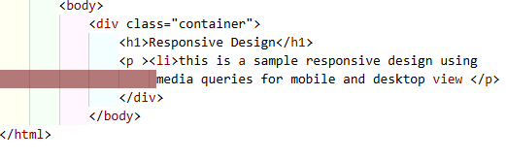

Output:
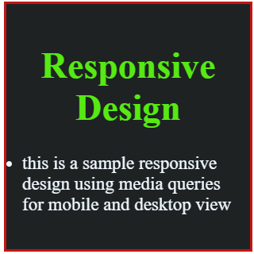

10.Design advance css with using section, header, footer and image tag.
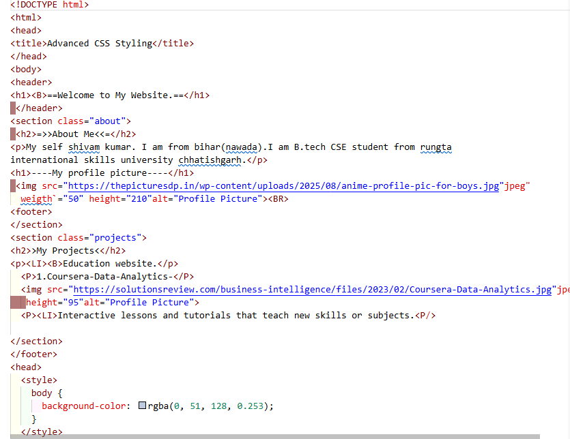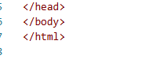

Output:
